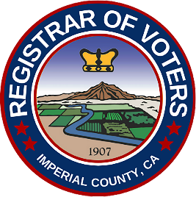

NOTICE OF MEASURE TO BE VOTED ON
NOVEMBER 3, 2026 STATEWIDE GENERAL ELECTION
Notice is hereby given that the following measure will be submitted to the voters of Imperial County at the General Election to be held on Tuesday, November 3, 2026:

Measure (Letter to be determined)
WESTMORLAND UNION ELEMENTARY SCHOOL DISTRICT

To improve athletic facilities at Westmorland Elementary School; repair restrooms; upgrade outdated heating, ventilation, and electrical systems; repair, construct, acquire classrooms, sites and equipment, shall the Westmorland Union Elementary School District’s measure be adopted to issue $2,800,000 of bonds at legal rates, levy approximately $25/$100,000 of assessed value, generating approximately $218,799 annually while bonds are outstanding, with annual audits, independent citizens’ oversight, NO money for salaries, all money staying local?

YES ☐ NO ☐

Pursuant to the California Elections Code, the deadline for filing primary arguments for or against the measure is 5:00 p.m. on Friday, August 3, 2026.
Arguments shall be filed with the Imperial County Registrar of Voters, 940 West Main Street, Suite 206, El Centro, California.
For additional information regarding the filing of ballot arguments, please contact the Imperial County Registrar of Voters at (442) 265-1060.
ABOVE NOTICE GIVEN THIS 20th day of July, 2026.

Linsey J. Dale
Registrar of Voters

